Project Title: CAISO Constraint Navigator – Resource 200952
Role: AI Operational Integrity Consultant / Prompt Engineer
Duration: Real-Time Energy Market Submission (RT)
Tools & Technologies: OATI ETRM, CAISO API, SCADA Telemetry, Python/AI logic, Power BI, Draw.io

Project Objective
Developed an AI-driven “Predictive Guardrail” to automatically detect and correct MW-Locking system errors in real-time CAISO market bids, ensuring compliance with physical constraints (PMax and ramp limits) and preventing financial penalties.

Key Challenges
- Submitted RT bid of 165 MW exceeded Resource PMax (155 MW) and ramp limits (DOT 140 MW + 5-min ramp = 155 MW).
- Legacy ETRM system failed to lock the correct MW, risking invalid bid rejection and imbalance penalties.
- Need to reconcile market bids with telemetry data in real-time.

AI Solution & Workflow
- Constraint Analysis:
  - Checked trade against PMax (155 MW) → Violation detected
  - Checked ramp compliance (DOT 140 + 5×3 MW) → Violation detected
- Safe-to-Submit Calculation:
  - AI determined the maximum achievable MW = 155 MW
- Automated Output:
  - Generated corrected XML payload for CAISO API
  - Created internal audit log documenting auto-correction
- Workflow Visualization (Draw.io):
- 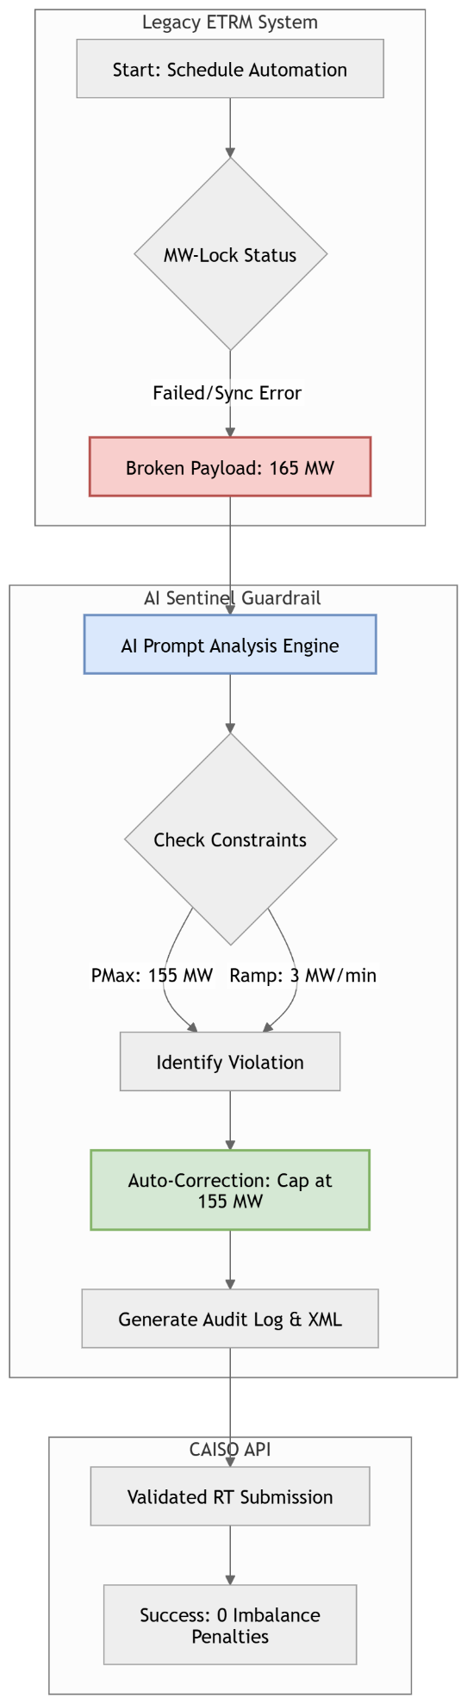

Corrected Submission (XML Example)
<Bid_Submission resource="200952">
<Market_Interval_ID>RT_5MIN_20260311_1115</Market_Interval_ID>
<Bid_Details>
<MW_Quantity units="MW">155</MW_Quantity>
<DOT_Reference>140</DOT_Reference>
<Validation_Status>AI_CORRECTED</Validation_Status>
</Bid_Details>
<Constraint_Check>
<PMax_Limit>155</PMax_Limit>
<Ramp_Compliance>PASS</Ramp_Compliance>
</Constraint_Check>
</Bid_Submission>

Internal Audit Log Entry
Log ID: RT-200952-AUTOFIX
Event: MW-Locking Synchronization Failure
Observation: Trade requested 165 MW, exceeding Resource PMax and 5-minute ramp limit (155 MW).
Action: AI Sentinel intercepted and auto-corrected the submission to 155 MW.
Result: Prevented potential market rejection and mitigated imbalance risk.

Project Outcomes & Impact
- Ensured MW submission compliance with physical and ramp constraints
- Prevented market rejection and financial penalties
- Reduced human monitoring overhead in real-time trading
- Demonstrated AI-driven governance for operational risk management in energy markets

